Mrs. Streich’s 1st/2nd Grade Supply List

Below you will find a list of supplies that your child will need for the year. It is a good idea to put your child's name on everything with a permanent marker to avoid confusion.

* 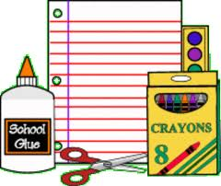1 plastic pencil box to hold supplies
* washable markers (Crayola 8 count is preferred)
* 24-pack (or less) crayons
* 1 or 2 highlighters (any color)
* 1 large eraser or 3-4 cap erasers
* 1 pair of scissors
* 1 folder
* 1 (4-pack) package of dry erase markers
* headphones for the computer lab (please AVOID earbuds)
* 1 tablet of drawing paper for their own use during free time
* watercolor paint set (Prang or Crayola is recommended)
* 10-20 gluesticks (we will combine all and use throughout the year)
* 2 packs of regular, yellow #2 pencils (we will combine all and use throughout the year)

\*\*Optional\*\*

1 box of Kleenex

1 container of Lysol/Clorox wipes

Thank you for helping to make your child's school year a success by supplying them with the necessary materials for learning!

Mrs. Streich